Figurative Language In A Song
Kryptonite by Three Doors Down

"Kryptonite"

I took a walk around the world
To ease my troubled mind
I left my body lying somewhere
In the sands of time
But I watched the world float
To the dark side of the moon
I feel there is nothing I can do, yeah

I watched the world float
To the dark side of the moon
After all I knew it had to be
Something to do with you
I really don’t mind what happens now and then
As long as you’ll be my friend at the end

If I go crazy then will you still
Call me Superman
If I’m alive and well, will you be
There a-holding my hand
I’ll keep you by my side
With my superhuman might
Kryptonite

You called me strong, you called me weak,
But still your secrets I will keep
You took for granted all the times
I never let you down
You stumbled in and bumped your head,
If not for me then you'd be dead
I picked you up and put you back on solid ground

If I go crazy then will you still
Call me Superman
If I’m alive and well,
Will you be there a-holding my hand
I’ll keep you by my side
With my superhuman might
Kryptonite

If I go crazy then will you still
Call me Superman
If I’m alive and well, will you be there
Holding my hand
I’ll keep you by my side
With my superhuman might

Oh, whoa, whoa
Oh, whoa, whoa
Oh, whoa, whoa
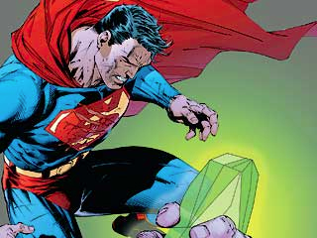
("For Marketers: Kryptonite That Will Overcome Attorney Objections - LawMarketing.com - The Premier Resource For Information on the Business of Law." The Premier Resource For Information on the Business of Law. N.p., n.d. Web. 01 Dec. 2014)
This picture is symbolism of the weaknesses and strength of superman who is being spoke of in this song. The author of the song is comparing himself to the goods and bads of superman who he wants his girlfriend to believe that he is superman.

